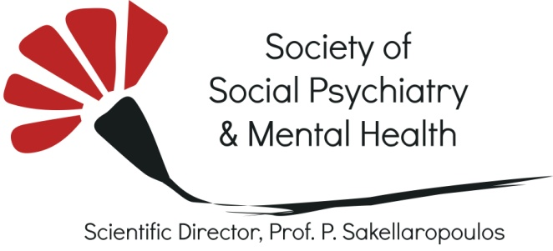

HOW THE MOBILE MENTAL HEALTH UNIT TEAM (AND IN GENERAL EKP&PSY) WORKS WITH YOUNG PEOPLE ON THE GOAL OF PREVENTION AND PRIMARY INTERVENTION IN MENTAL HEALTH

GENERAL CONCEPT
EKP&PSY, especially through the work done for the population of remote areas from our Mobile Psychiatric Units, focuses very much to the prevention and primary intervention for young people at risk.
We work in a twofold way:
- Directly with young people and adolescents who are diagnosed with MH problems, providing therapy and also supporting them to (re)integrate to their family, social environment and school or to the labour market. We always include work with the family/ psycho-education and with the immediate environment. We offer a package of combined methods: psychotherapy and medication if necessary, other methods of therapy such as art therapy and psychosocial rehabilitation-socialization groups, intervention at home during crisis, support and sessions for the family, support to the re-integration in school and support to the teachers, networking with other social services, interventions in the judicial authorities if necessary.
- Indirectly, through community awareness raising, seminars to teachers and relevant social services, municipality, authorities, the church, the judicial authorities and any group of the community that might be the formal or informal point that can reach young people and families (at risk) or can be the bridge between young people and our services and help with the rehabilitation of these people. We use every conventional and alternative way to reach people: seminars, workshops, art and culture events, local events etc.

THE WORK WITH YOUNG PEOPLE/TEENS IN THE COMMUNITY
Through the long-term work with the school community in the domain of Fokida, the mobile team lately has stabilized its own functioning within the premises of the Schools visiting. The work on prevention targets all groups of interest teens, parents, and teachers. The groups are differentially and separately treated with the main purpose being that of enhancing and facilitating communication and awareness within.
Analytically, working in a school community, yearly (September-April), involves:
- Every second week a project named “ teen teams” targeted to a certain group of young people that is usually a class with approximately 10-15 persons
- Every second week a seminar is delivered to a certain group of teachers, usually around 30-35 persons
- Every 3 months, presentations are given, open to the public, but mainly focused on parents of children and young adults.
- Once a year takes place a big fest, where the young people express themselves in different ways through mini projects, theatrical pieces, music concerts, etc.

“Teen teams”
The project: “teen teams” is scheduled to be delivered into the everyday school timetable, and it takes place within the classroom. Certain proofs of agreement are given from the Ministry of Education and from the administrative department of Secondary Education. The aims of the project are:
- To enhance self-awareness, and encourage young people to find appropriate ways to express themselves.
- To enhance awareness and better knowledge on puberty and about the changes that occur on the onset of puberty.
- To enhance self-esteem and encourage young people to make positive attributions to ones self.
- To enhance awareness and understanding of mental health issues and to promote positive attitudes towards people with mental health problems so as reduce stigma.
- To increase awareness on bullying and educate about appropriate ways of coping with it.
- To enhance team work, “togetherness”, and encourage communicative and cooperative skills in young people.
Relevantly, the issues that are covered are usually proposed from the young people and express their mainly concerns.

The procedure:
The project “teen teams” is delivered in 7 high schools in the prefecture of Fokida. It was a pilot project that is expanded in schools in Attica and prefecture of Evros as well. The choice of the group of students that will be targeted each year, it depends mostly on the decision of each school principle and each school board. Usually the young people and their parents sign a confirmation paper priory were they give their consent to join the project. The project is delivered at the same time and day, within the timetable, whilst duration of the programme. The group of teens should not exceed the 15 persons.
Each workshop lasts usually an hour approximately. Each workshop is delivered as follows:
- The specialist introduces the subject of the workshop and continues a mini discussion that concerns of the understanding of the issue.
- The specialist introduces the way that the subject under matter will be addressed. Usually the team is split into smaller teams and work on specific tasks.
- Then each small team introduces its outcome in the whole team.
- In the end, a conclusion that summarizes the outcomes is presented by the specialists.
The mobile psychiatric unit promotes prevention and primary intervention for young people through community awareness raising. In relevant seminars are delivered to teachers, parents, people from the community, staff from local authorities, social services and staff from emergency and safety services, etc.
The seminars are delivered each second week and usually each seminar lasts 2 hours approximately. The seminar takes place in the offices of the mobile psychiatric unit. The programme and the subjects that will be addressed are organized by the specialist and the dissemination takes place at the beginning of the calendar year.
The aims of the seminar are:

- To raise awareness and understanding of mental health issues, in general population.
- To enhance awareness and understanding of mental health issues in young people especially between the ages of 12-18 years.
- To reduce the bridge and bring together parents and their young children.
- To enhance awareness of youth issues and encourage communities and local authorities to approach young people in appropriate ways.
Iliana Lazogiorgou
Panagiota Fitsiou
Athena Frangouli
Panagiotis Sakellaropoulos

